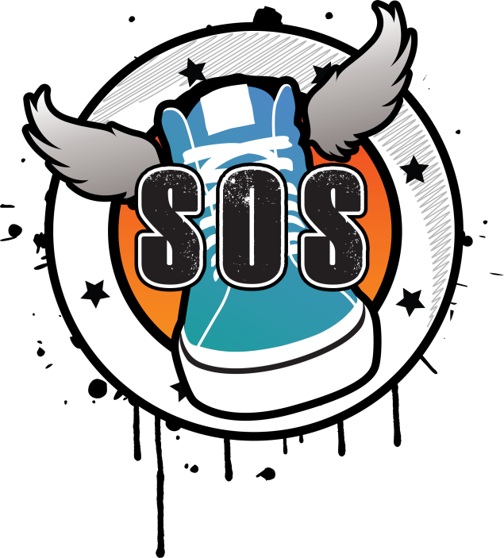

SKOOL OF STREET
ANNUAL REPORT

August 2015 – July 2016

Registered Charity no : 116731
Our Mission

- Inspiration without Discrimination
- To advance education for the public benefit by the promotion & teaching of the arts.
- To provide and assist in the facilities in the interest of social welfare.

The Firm

This year has been an exciting year for us, the charity has continued to grow from strength to strength. Due to core investment this year we have been able to offer young people in Blackpool the opportunity to take part in FREE performing arts activities based around the culture of Hip Hop & Theatre. This annual report will demonstrate how we are making a difference in young people’s lives across Blackpool, Wyre & Fylde. Our service continues to offer free training and accredited volunteering opportunities & a better sense of wellbeing within the local community. We see funding from, local business, sponsorships, The National Lottery Funding through Awards for All, Arts Council Funding & donations from National Trusts to pay instructors, venue hire & materials.

Professional specialist performing arts instructors team up with young people, volunteers & community workers to develop the local community through the arts, to advance mental, physical & social welfare, to help improve their conditions of life. We emphasize on children from deprived areas, young people and families across the Fylde Coast. Many of the young people are now looking towards a career in the arts.

Trustees

- Lauren Kayley – Chair
- Lisa Jodrell – Treasurer
- Leah Houghton - Secretary

Volunteering

Wingz Academy takes place every Saturday morning at Revoe Children's Centre providing free performing arts activities to young people in the area. Young mentor volunteer providing assistant to specialist session workers in dance, singing and theatre. Skool of Street runs in school holidays providing free urban activities at The Oracle Young Peoples centre. Again young volunteers assist over their holidays in the provision of the sessions. Activities include graffiti art, street dance, physical theatre, and rap/spoken word, working towards a final performance for friends, family and the community.

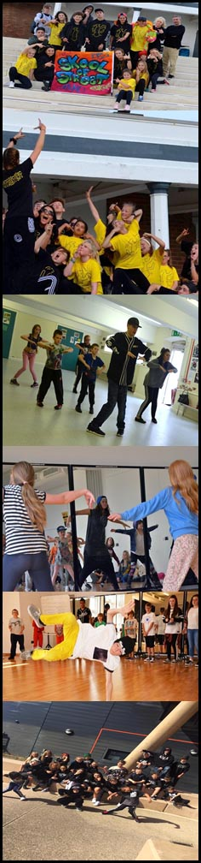
SUMMARY OF MAIN ACTIVITIES

SUMMER 2015 – STREETFEST

Skool of Street was awarded funding to provide free workshops in Fleetwood by Wyre Borough Council resulting in a Free Family Hip Hop Youth Festival at the Fleetwood Marine Hall Gardens. Young people took part in sessions at Cardinal Allen School where they were taught Street dance, Drama, DJ Skills, Rap & spoken word. Pieces of theatre along with live graffiti art were created using these art forms at the festival for family, friends & members of the public.

WORKSHOPS & FREE TRAINING

JANUARY 2016 – Wingz Academy
Wingz Academy provides FREE performing arts activities on a Saturday mornings at Revoe Community Centre for low income families. Young volunteers assist with sessions as each class is broken down into appropriate age groups.

SPRING/SUMMER 2016

We planned our activities for the summer holidays keeping in mind the Charity's guidance on public benefit. The focus on our activities for the summer was creating a piece of theatre for young people to be engaged in and be inspired by; we also wanted to engage new members who had never performed on stage before through our community projects. Funding was granted by Arts Council England to provide a professional piece of Hip Hop Theatre using Young People & professionals called Popnocchio 75 young people took part in front of 534 members of the audience. Further funding was granted from The National Lottery to provide workshops over 5 weeks at The Oracle building, resulting in a performance at The Grand Theatre as the Popnocchio curtain raiser in September. Further donations we raised through, fundraising, local business', national trusts such as the Community Foundation & Margaret Guido Charitable Trust to support our instructors going into local schools and colleges as a way of engaging more people in the arts who wouldn't normally do so.

During our summer workshops 183 young people engaged in Skool of Street 20 of which completed their Bronze Arts Award, our summer projects & creating a piece of theatre have benefitted young people by developing their performance skills, self-confidence, social skills, accredited volunteering opportunities through URPotential, thus giving them an overall sense of achievement and better wellbeing.

EVENTS

ACCENTURE
TEAM BUILDING PERFORMANCE
Viva Show bar Blackpool

SKOOL OF STREET
XMAS FUNDRAISER
NYX Bar

SKOOL OF STREET
HALF TERM FUNDRAISER
NYX Bar

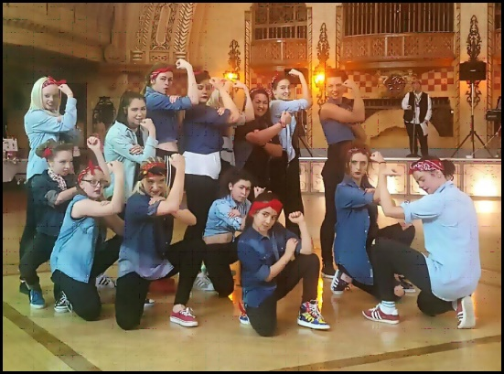
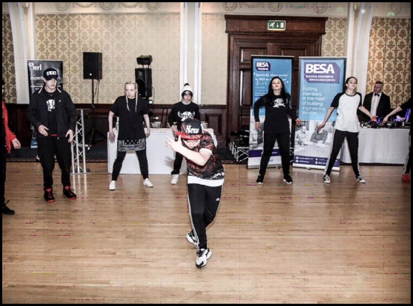

BESA EVENT
Imperial Hotel Blackpool

INTERNATIONAL WOMEN’S DAY
Ran by URPotential – Performances throughout the day at the Winter Gardens Blackpool

SKOOL OF STREET
Produces & records their own track Funky Flow to perform at Fundraiser events.

BREAKIN’ CONVENTION 2016 TOUR

STREETFEST PRESTON
Preston County Council commissioned us to do a FREE Community Hip Hop Festival outside the Harris Building.

Queen’s Birthday Weekend
Performances at Blackpool Pleasure Beach to celebrate her majesty's birthday.

ICAN Hub Launch/Rupert Fabulous
Stanley Park Bandstand our young mentors performed for a crowd of over 1000, donations were given by members of the public to support further work in the community.

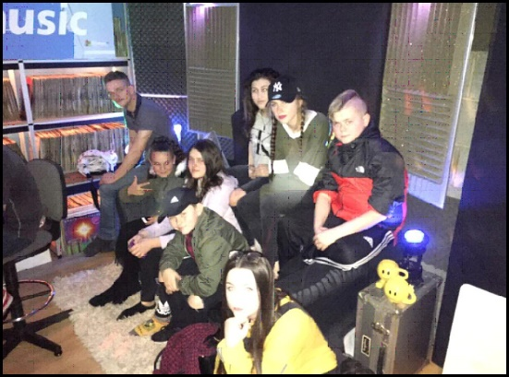
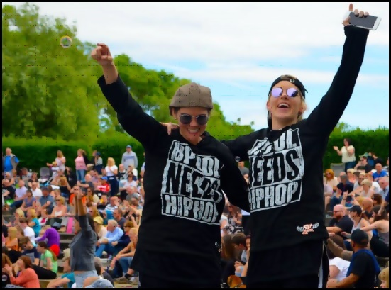
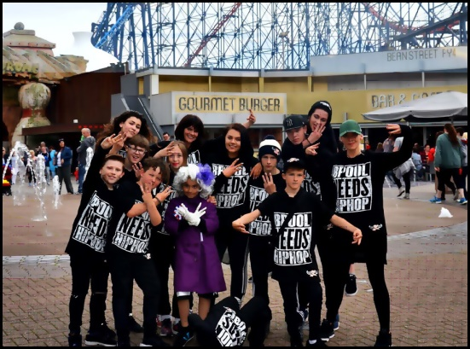
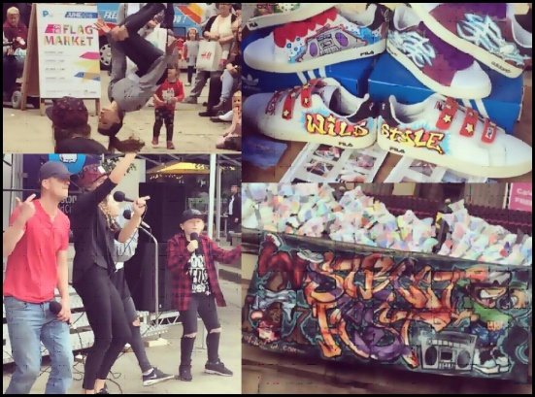
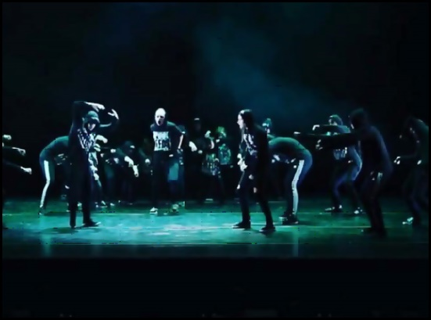

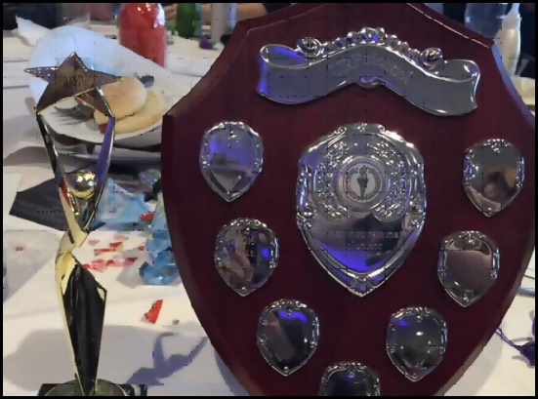
URPotential Awards Ceremony Performance BFC
Our young volunteers performed & were presented with certificates for their volunteering hours. One of Skool of Streets very own young mentors was awarded with the Youth Volunteer of the year award.

Leftcoast's Spare Parts Festival
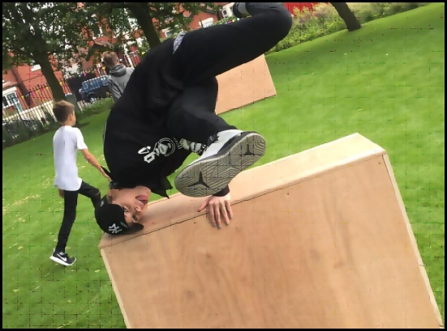
Commissioned to do a transport based piece of theatre & Parkour

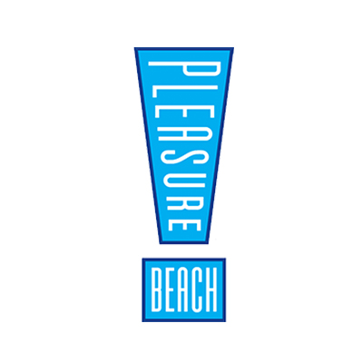
IN 2015/2016
WE WERE
SUPPORTED BY
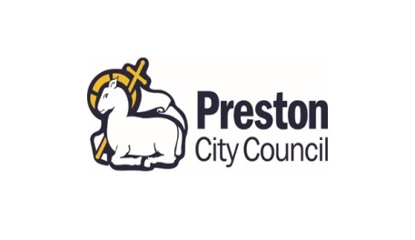
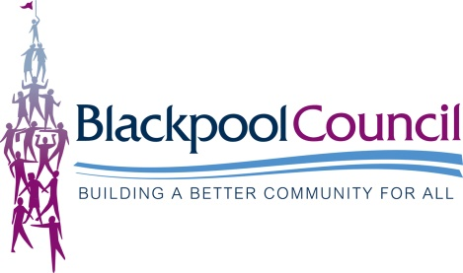
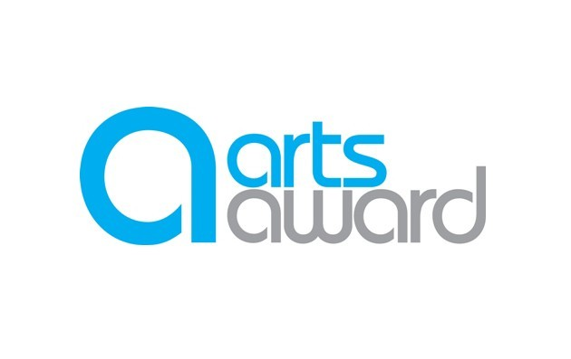
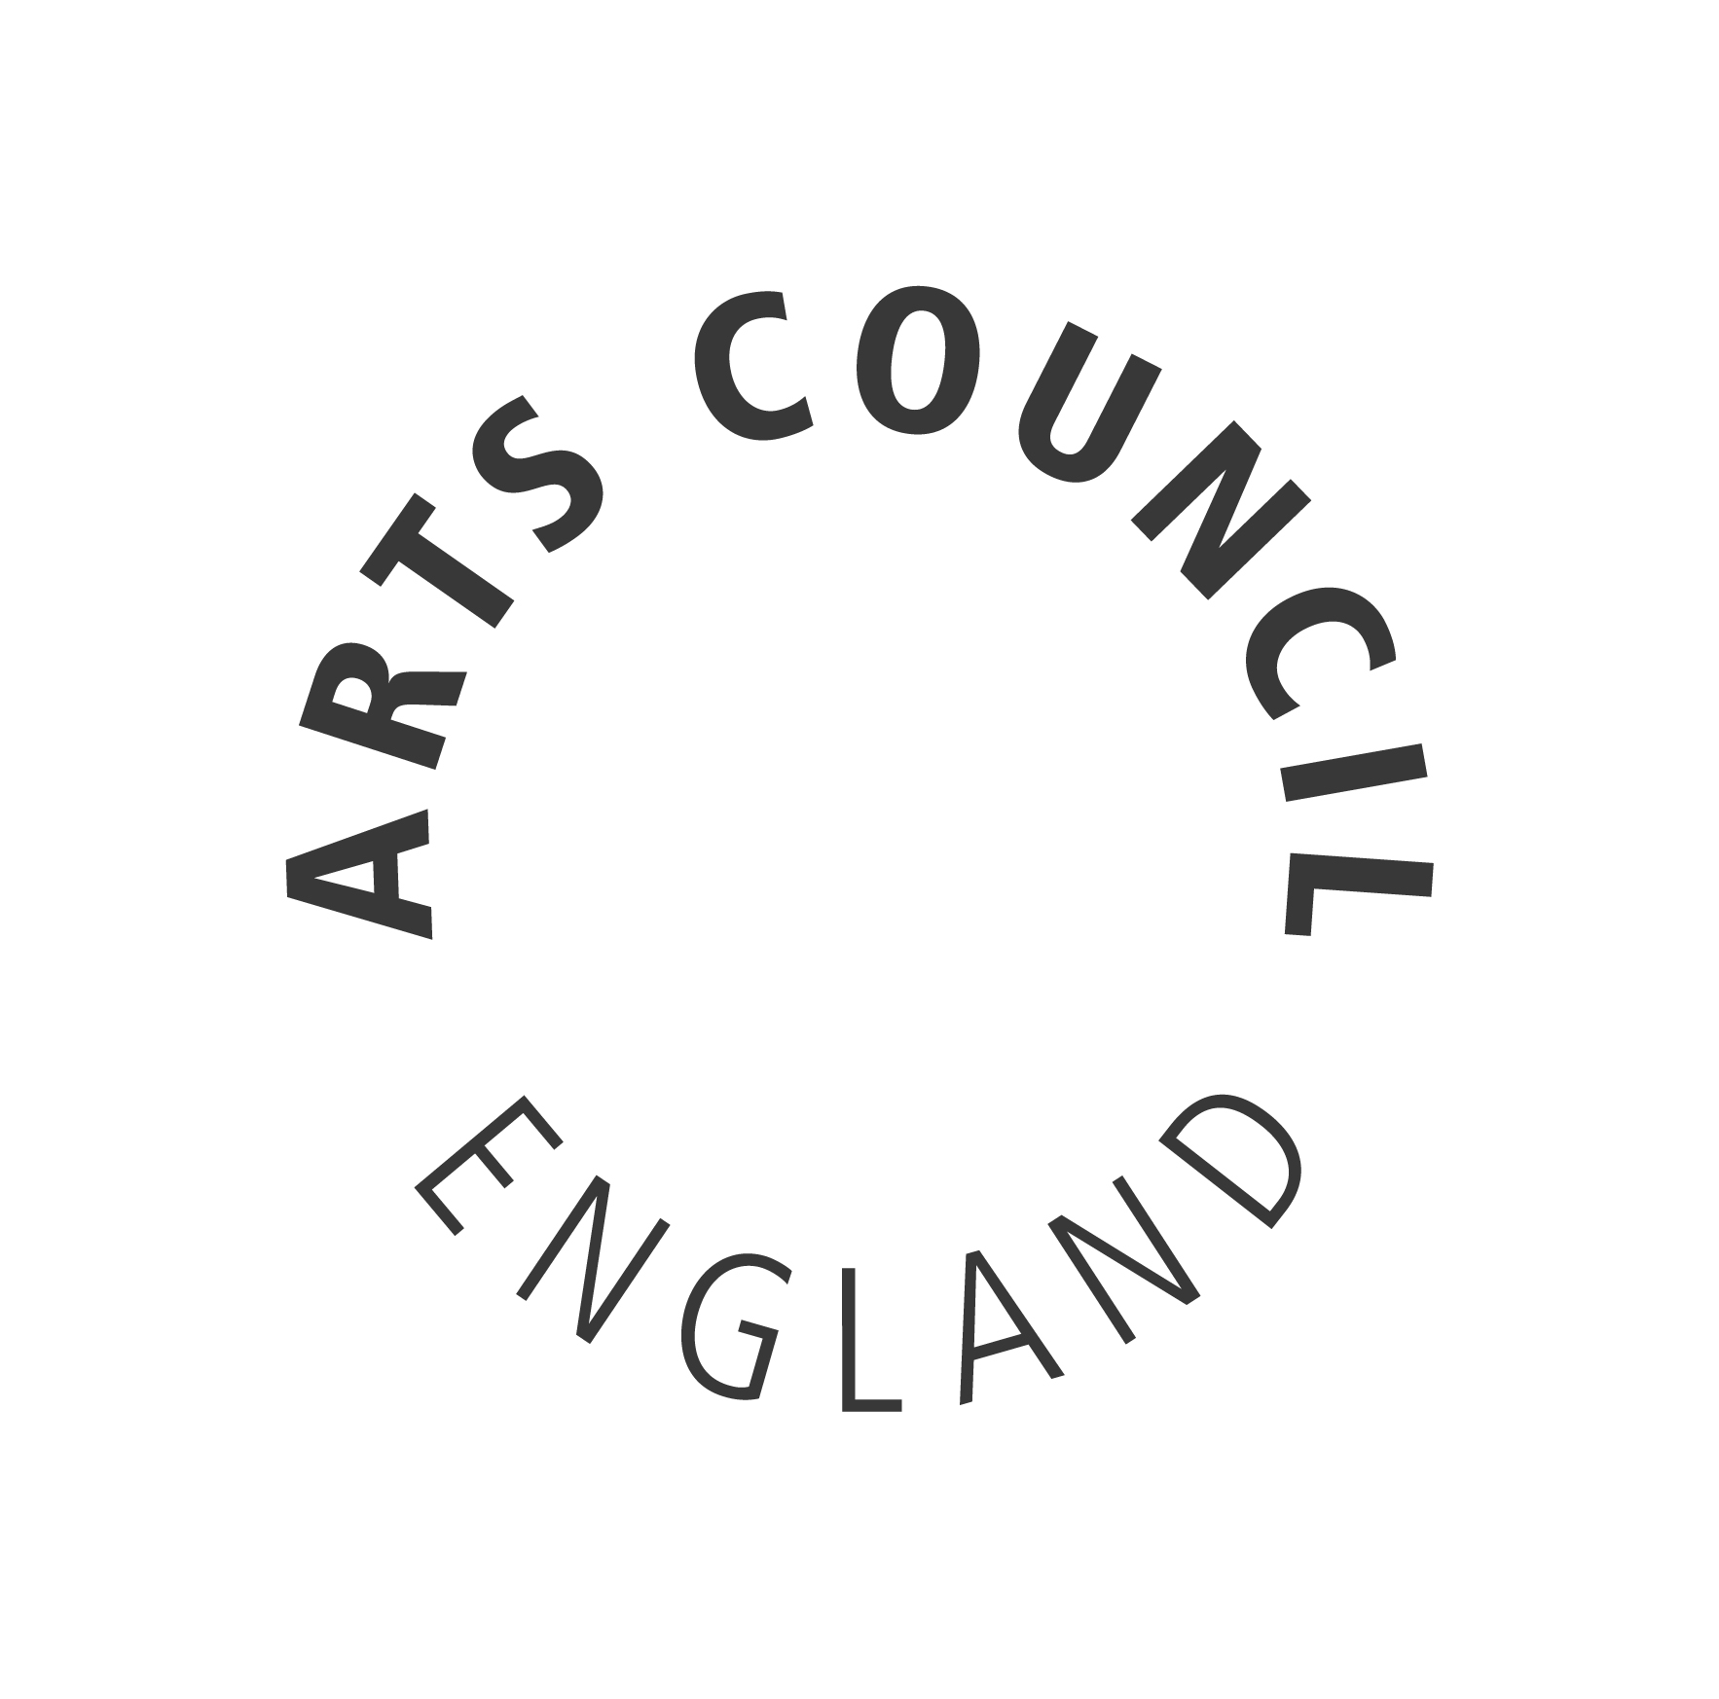
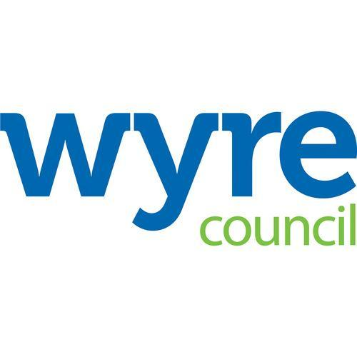
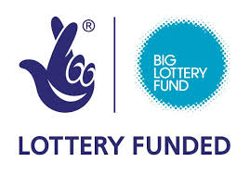
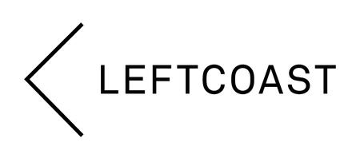
MEMBERS SINCE
JULY 2014

Gemma Knight
Andrew Finlayson
Charlotte Bee
Jason Stanley
Naomi Kalina
Nicola Whitehead
Linda Markey
Kerry Hindley
Kellie Smith

Workshops/  Events | Audience | Participants
Streetfest | 123 | 213
Wingz Academy | 63 | 153
Skool of Street Summer 2016 | 75 | 534
Breakin' Convention | 30 | 800
ICan Launch/ Fundraiser | 20 | 2000
SpareParts Festival | 18 | 2400
Revoe Learning Academy Sessions | 360 | 400
URPotential Awards Evening | 14 | 130

Thank you to all the team, instructors & volunteers for their hard work and dedication towards Skool of Street.

We look forward to working with you all in the future.

Massive thank you to all our funders and partners for supporting Skool of Street.

Skool of Street, 3 Ashfield Road, Blackpool, Lancashire, FY2 0DH
TEL: 01253 298375
EMAIL: skoolofstreet@live.com
WEBSITE: www.skoolofstreet.com

